**X First Nation Land Relationship Vision Assessment Report**



<Insert First Nations Community Name>

<Insert date>

Table of Contents

1. Background 3

Introduction 3

Indigenous Knowledge 3

Community Vision 3

Your Community 4

2. METHODS 5

Who was involved in your project 5

Working Committee Members 5

Working Committee Meetings 5

When & How 6

Community Engagement Events 7

Technical Support & Training 8

Where 8

3. RESULTS 9

FINDINGS AND ANALYSIS 9

What we found 9

What we Heard 9

Where are the key locations 9

4. Conclusions & Next steps 10

Project KEY FINDINGS 10

Project reflections 10

Next STeps 10

Appendices 12

Appendix A: *INSERT FIELD SHEETS, Maps, meeting notes, etc here* 12

# Background

## Introduction

Purpose: Why was this work completed? What is the purpose of the report?

|  |
| --- |
| If you have specific goals and objectives for your work list them here.  If your project has a specific focus record it here. For example, terrestrial assessment; aquatic assessment; Species at Risk assessment; bio-cultural species assessment; habitat or ecosystem assessment; and/or natural spaces of particular importance to your First Nation. |

## Indigenous Knowledge

This section integrates Indigenous knowledge and perspectives with important species and spaces into the plan.

|  |
| --- |
| *E.g. Explain how your values or perhaps a traditional teaching relate to responsibilities for protecting important species and spaces.* |

## Community Vision

Write your First Nation’s Vision Statement and describe how protecting important species and spaces relates to your community’s vision.

|  |
| --- |
|  |

## Your Community

Write a paragraph about your community. Include details such as community history, population, location, traditional territory, treaties, land management, etc.

|  |
| --- |
| Example: <name of community> We are located XX km northwest of <nearest major city>. Our population is 1,200 residents. The Lands Department provides x, y, z. and is responsible for <acreage of reserve>. Our traditional territory covers x area (describe boundaries). Treaties with the Crown are x…  *INSERT MAP(S)* |

# METHODS

## Who IS involved in your project

Write a paragraph about who was involved in this project.

|  |
| --- |
| Who is writing this report, what department, who can be contacted for more information?  Who did the field work, including any volunteers and/or contributions from the community?  If you involved others from outside of the community as resource people, please list them, their affiliation and role(s).  INSERT PHOTO(S) |

## Working Committee Members

List the members of your community’s working committee if you had one.

|  |  |  |  |
| --- | --- | --- | --- |
| (Note contact information should remain private and not included when sharing your report)**Name** | **Position** | **Affiliation** | **Contact Information** |
|  |  |  |  |
|  |  |  |  |
|  |  |  |  |
|  |  |  |  |
|  |  |  |  |
|  |  |  |  |
|  |  |  |  |
|  |  |  |  |
|  |  |  |  |

## Working Committee Meetings

List the meetings for your community’s working committee.

In <date when the working committee was formed>, interested members from <name of First Nation’s community> were invited to join this working committee. A total of <number of meetings> were held. The committee visited various locations in the community to identify and discuss important species and spaces.

|  |  |  |
| --- | --- | --- |
| **Date (YYYY/MM/DD)** | **Location** | **Description/Purpose** |
| *2021/04/02* |  |  |
|  |  |  |
|  |  |  |
|  |  |  |
|  |  |  |
|  |  |  |
|  |  |  |
|  |  |  |
|  |  |  |

## When & How

You can provide key dates of your project using a simple timeline such as the example template provided below. Include dates of community engagement sessions and field work.

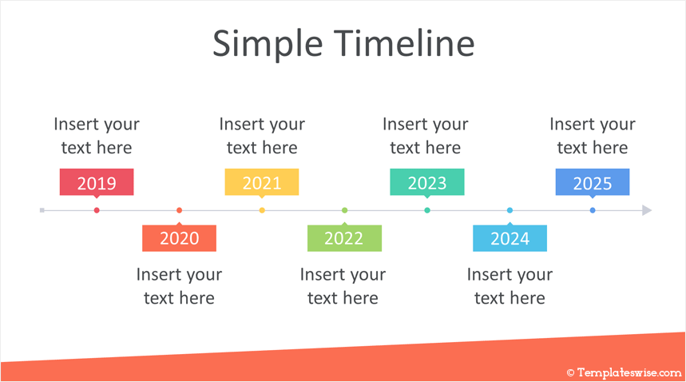

|  |
| --- |
| Describe your methods, especially if you used established surveying or landscape assessment methods, so others can replicate your work in the future  INSERT PHOTO(S) |

## Community Engagement Events

*Describe community engagement events that took place.*

Use the space below to document the actions you have taken to engage your community.

|  |
| --- |
| Describe how you engaged the community in your project and any communication techniques applied during the project  *Example: A total of <number of events> were held in <name of community>. The working committee heard from many community members about their concerns for species and spaces of importance to them, and their beliefs on what direction the community should take for protection. The photo below shows our first community open house, where the working committee posted information gathered on the community’s species at risk and natural heritage features that have already been identified.* |



## Technical Support & Training

List any technical support or training received by staff working on the project, the working committee (if you had one), and/or provided to the community (if that was part of your project). This will help future community researchers, not just understand what you did, but where they too can go for assistance with a project.

|  |
| --- |
| List any technical support or training here, including contact names and information.  INSERT MAPS & PHOTOS |

## Where

Describe where the activities occurred, including community events and field work.

Provide a map of locations identified by community members of locations where field work occurred.

|  |
| --- |
| Describe where all field activities occurred  Provide a map of locations for field work  INSERT MAPS & PHOTOS |

# RESULTS

## FINDINGS AND ANALYSIS

This section of your report is a space to discuss your findings, analysis, and present the outcomes of the work.

## What we found

|  |
| --- |
| *Summarize field forms, checklists and assessments. Tables and checklists can be presented here and/or included as appendices to your report.* |

## What we Heard

|  |
| --- |
| Summarize any community engagement sessions. What did you hear? A simple bulleted list of comments is enough or a summary of survey results if used. Include participants list as appendices to your report.  INSERT PHOTOS |

## Where are the key locations

|  |
| --- |
| Provide maps of results if possible, or include scans of marked up paper maps within the report. This section may be removed or edited depending on the sensitivity of information included. Do not release information about species at risk locations to the general public.  INSERT MAPS & PHOTOS |

# Conclusions & Next steps

This work may represent a first step in your work or may be part of a much larger project. Make note of that in this section.

Based on your reflections highlight your key findings and recommendations from this work.

## Project KEY FINDINGS

|  |
| --- |
| Summarize what you found out from doing this work… |

## Project reflections

|  |
| --- |
| Reflect on the project: what worked, what didn’t work, what would you do differently, what did you learn, and what would you like to do next? |

## Next STeps

|  |
| --- |
| *This work likely got you to think about next steps: more assessment work; concerns you or the community might have noted; opportunities you or the community identified, etc. Record these points here.*  Expanded Assessment Work?  Land-Use Planning? Protection Zones?  Monitoring? Developing a Guardians Program?  Education? More community engagement? Trail markers, posters, language and IK incorporation?  Create Protected Areas? Restore Areas? Maintain connection corridors?  Identifying Threats and Mitigation?  Training? Community naturalist group? Host bioblitzes? Create “Friends of” club  Partnerships? Other First Nations? External allies? |

# Appendices

## Appendix A: *INSERT FIELD SHEETS, Maps, meeting notes, etc here*